SIMPLE EVENT PHOTO GALLERY & APPROVAL
@CREATIVITY THINK (9483175986/7019689991)

ABSTRACT:
Simple Event Photo Gallery & Approval is a web-based platform designed to manage event photography workflows for colleges, schools, clubs, and small events. The system enables photographers to upload photos to specific events, track approval status, and make approved images available in a public gallery for viewing and downloading. Administrators oversee event albums, review uploaded photos, approve or reject content, optionally add watermarks, and monitor contributor activity through dashboards. Built using Django and Django REST Framework for backend processing, and React with Dropzone and axios for frontend interactions, the platform ensures secure, organized, and efficient management of event photos..

INTRODUCTION OF THE PROJECT:
Managing event photography involves coordinating multiple contributors, ensuring photo quality, and controlling public access to images. Traditional methods rely on emails or file-sharing platforms, leading to scattered files and lack of control over approvals. The Simple Event Photo Gallery & Approval system centralizes photo uploads, approval workflows, and gallery management, providing both photographers and administrators a structured, real-time platform to streamline photo sharing, approvals, and public display while protecting intellectual property through optional watermarks..

PROJECT OBJECTIVES:

• Provide a secure platform for event-based photo uploads
• Allow users to track the approval status of their uploaded photos
• Display approved photos in a public gallery for viewing and downloading
• Enable administrators to create events and albums, review uploads, and manage approvals
• Implement optional server-side watermarking for approved images
• Offer dashboards for monitoring uploads per event and contributor activity
• Allow export of contributor lists and photo metadata
• Ensure efficient and organized handling of large volumes of event photos
• Improve collaboration between photographers and event administrators

PROBLEM OF THE STATEMENT:
Event organizers and photographers often face challenges in managing photo uploads, approvals, and public sharing. Manual coordination through emails or cloud drives results in disorganized storage, delays in approval, and difficulty tracking contributors. There is also a lack of control over unauthorized access and intellectual property. This system resolves these issues by providing a centralized, structured workflow for uploading, approving, managing, and distributing event photos efficiently and securely..

MOTIVATION OF THE PROJECT:
• To streamline the workflow of event photography
• To provide a transparent approval process for uploaded photos
• To make approved photos accessible in a well-organized gallery
• To reduce manual coordination and mismanagement of files
• To protect image rights using optional watermarks
• To offer a user-friendly interface for photographers and admins
• To monitor contributor performance and event uploads via dashboards
• To provide actionable insights and data exports for record-keeping

BLOCK DAIGRAM OF PROJECT:

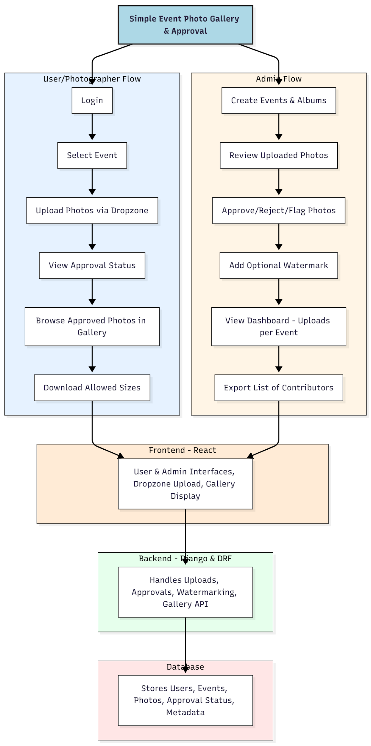

WORKING OF THE PROJECT:
Photographers log into the system, select an event, and upload photos using the Dropzone interface. Each uploaded photo enters an approval queue where administrators can review, approve, reject, or flag images. Approved photos are automatically displayed in the public gallery, with optional watermarks added by the backend. Users can browse approved photos and download them in allowed resolutions. Administrators can create events/albums, monitor uploads via dashboards, and export contributor lists. The backend handles API requests, photo storage, approval workflows, watermarking, and ensures all interactions are logged in the database for transparency and tracking..

SOFTWARE REQUIREMENT:
- Backend:
  - Python 3.x
  - Django
  - Django REST Framework
  - SQLite/PostgreSQL
- Frontend:
  - Node.js and npm
  - React.js
  - Axios
- Development Tools:
  - Visual Studio Code
  - Postman (for testing APIs)
  - Git/GitHub (for version control)
- Server/Deployment (Optional):
  - Gunicorn, Nginx, or Heroku/AWS for hosting

ADVANTAGES OF THE PROJECT:

• Streamlined event photo management workflow
• Centralized approval system for photos
• Public gallery for approved images
• Optional watermarking for image protection
• Dashboard insights for administrators
• Easy monitoring of uploads per event and contributors
• Exportable data for record-keeping
• Reduces manual coordination and file mismanagement

APPLICATIONS OF THE PROJECT:
• College and school events
• Club events and community gatherings
• Small corporate or private events
• Photography contests and exhibitions
• Any event requiring organized photo approval and sharing

REFERENCES:

- Django REST Framework Documentation — Django Software Foundation. Django Documentation. Available: https://docs.djangoproject.com/
- Django REST Framework. DRF Documentation. Available: https://www.django-rest-framework.org/
- React. React Official Documentation. Available: https://reactjs.org/docs/getting-started.html
- Redux. Redux Documentation. Available: https://redux.js.org/introduction/getting-started
- PostgreSQL Global Development Group. PostgreSQL Documentation. Available: https://www.postgresql.org/docs/
- MySQL. MySQL Reference Manual. Available: https://dev.mysql.com/doc/
- Git. Git Documentation. Available: https://git-scm.com/doc
- Node.js. Node.js Documentation. Available: https://nodejs.org/en/docs/
- Axios. Axios Documentation. Available: https://axios-http.com/docs/intro
- Socket.io Documentation – https://socket.io/docs/

